Hyperbilirubinemia Risk Nomogram and Phototherapy Curve
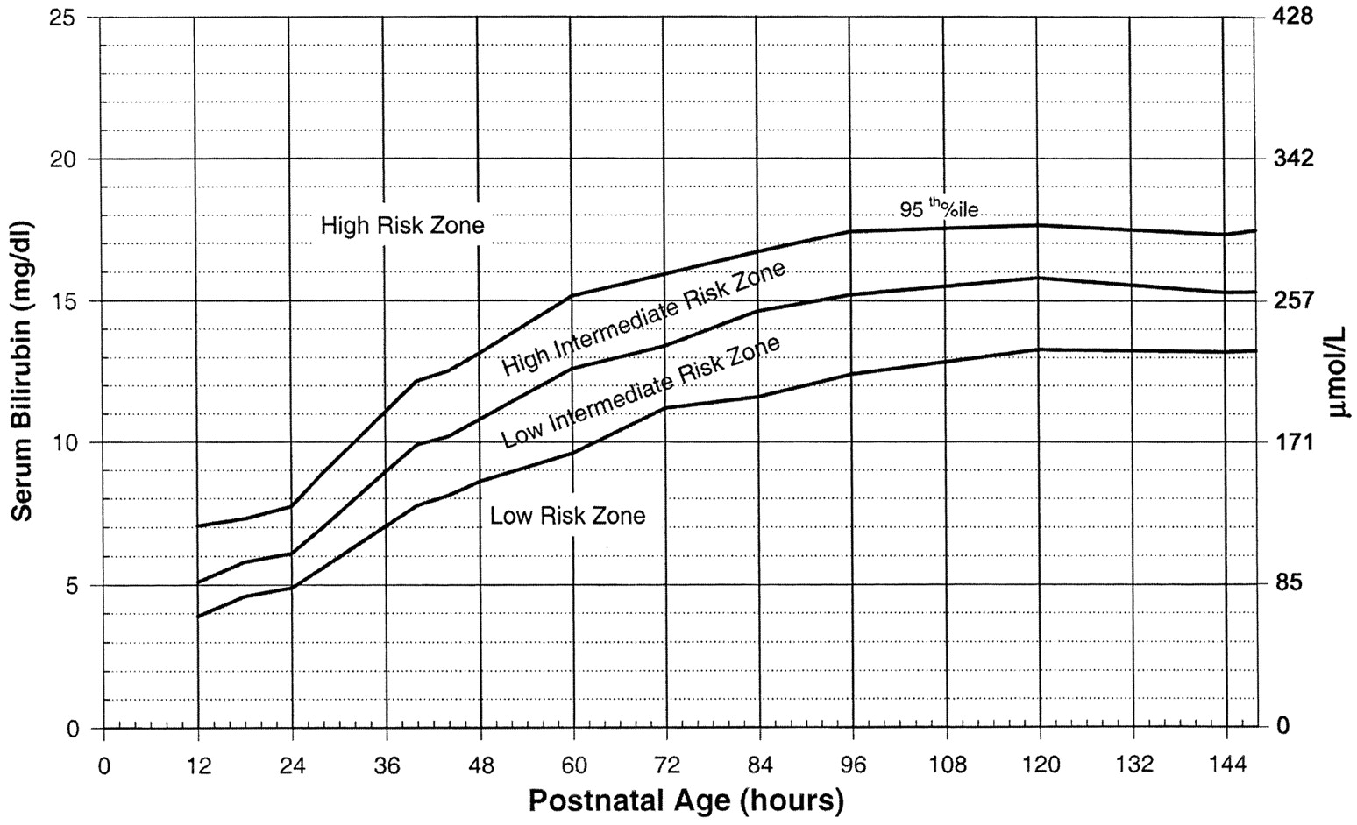

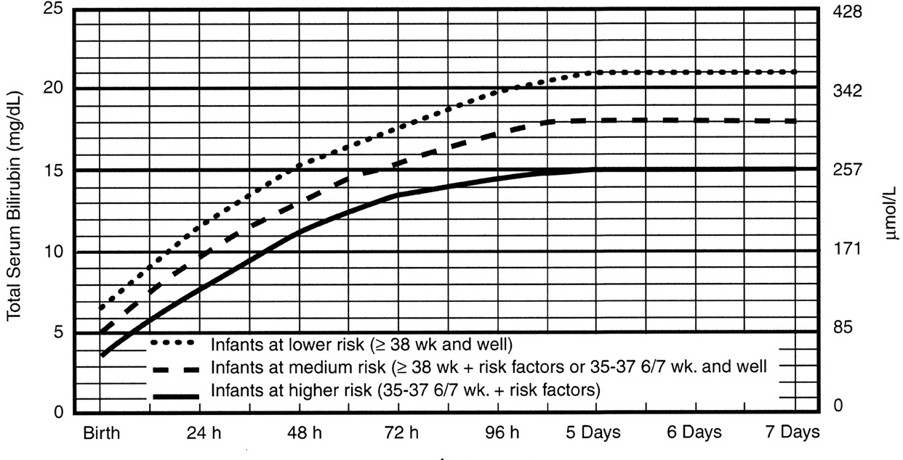

Risk factors for unconjugated hyperbilirubinemia
MAJOR RISK FACTORS | MINOR RISK FACTORS | DECREASED RISK
- Pre-discharge bili in the high risk zone  - Jaundiced at <24 HOL  - ABO incompatibility with DAT+  - Other hemolytic disease (G6PD etc)  - Premature (<37 wga)  - Previous sibling received phototherapy  - Cephalhematoma or significant bruising  - Exclusive breastfeeding (especially if feeding poorly or excessive weight loss)  - East Asian | - Pre-discharge bili in high-intermediate zone  - Early term (37-38 wga)  - Jaundiced before discharge  - Previous sibling with jaundice  - Macrosomic infant of diabetic mother  - Maternal age >25 years old  - Male | - Pre-discharge bili in the low risk zone  - Gestational age >41 weeks  - Exclusive bottle feeding  - Black race  - Discharged from hospital >72 HOL

Risk factors for severe neurotoxicity (phototherapy curve)
- Hemolysis
  - Isoimmune hemolytic disease: ABO incompatibility with DAT(+), with or without evidence of hemolysis (high retic, anemia, etc)
  - G6PD deficiency: Blacks (16% men, 8% women), East Asians, Mediterranean descent. X-linked.
- “Sick infant”: asphyxia, significant lethargy, temperature instability, sepsis, acidosis
- Albumin < 3.0 g/dL: bilirubin is bound to albumin en route to the liver for conjugation. Low albumin -> less transport capacity -> less excretion!

ABO incompatibility and hemolysis (isoimmunization)
- If mom is type O, cord blood should be sent automatically – but verify!
  - 40% will have incompatible bloodtypes, and 33% of those will be DAT+
- O/A incompatibility (31%): more common; tends to be less severe
- O/B incompatibility (9%): less common; tends to be more severe
- Rh incompatibility (DAT+): Check Hgb/Hct/retic/NBili at 6 hours of life
  - A high NBili implies significant intrauterine hemolysis
  - A high retic implies an attempt to compensate for intrauterine hemolysis
Bilirubin – Miscellaneous and Pearls
Nursing will do a TcB if they think a baby looks jaundiced, is losing too much weight, or has difficulty feeding; if above the following reference level, they will automatically draw and NBili and notify you. TcB is not accurate >= 13.5
TcB Level | Hours of Life | If the TcB value exceeds the level in the far left column, draw a serum nBili and notify the Pediatric provider
≥6 | 12-14
≥8.5 | 24-30
≥9.5 | 30-36
≥10.5 | 36-48
≥12 | 48-60
≥13 | 60-72
≥13.5 | >72

When to order follow-up levels:

Bilitool cautions:

Rate of rise:

If sample is hemolyzed redraw and get a venous stick (otherwise bili falsely elevated)

Try to sync bili across multiple babies for ease of following (if clinically appropriate)

When to get a rebound (s/p 8-12 hrs)

Not checking more frequently than 8-12 hours unless significant risk of hemolysis

All data is derived from Rh kids, not ABO, so it is an assumed risk factor.

Babies CAN get cold with new lights, hence q1hr vitals

If bili not dropping as expected, think first of mechanical issues – baby obstructed from lights? Lights on, and at high intensity? Appropriate distance/angle? Parents taking kid out from under the lights? Giant diaper on tiny baby? Etc

Quality/frequency of feeding has some impact on bilirubin, but typically isn’t enough to make or break the deal.

Proper rebound for higher risk babies: @12hr x2; sooner is too soon and you may catch a “bump” that occasionally occurs.

Light intensity: >= 30 microwatts/cm^2/nm, above which there are rapidly diminishing returns
Light wavelength: 425-475 nm

Breast milk jaundice can last 2-3 months!

Fluxometer – checks light intensity. Notice how it changes as you change the angle!

Absolute | Recommended
10% loss of birth weight | Gestational Age 35-36 weeks
Poor feeding | Sibling received phototherapy
Excessive bruising
Possible blood group incompatibility (Mom’s blood type O+ or O-)
Visible jaundice

These studies found the BiliCheck accurately correlated with TSB in infants with all types of skin pigmentation with a tendency to underestimate the serum bilirubin level when TSB was greater than 15.,,, BiliCheck requires five samples to be drawn to obtain an average TcB. A new disposable tip is required for each infant tested.

- TABLE 4.
Risk Zone as a Predictor of Hyperbilirubinemia³⁹
TSB Before Discharge | Newborns (Total = 2840), n (%) | Newborns Who Subsequently Developed a TSB Level >95th Percentile, n (%)
High-risk zone (>95th percentile) | 172 (6.0) | 68 (39.5)
High intermediate-risk zone | 356 (12.5) | 46 (12.9)
Low intermediate-risk zone | 556 (19.6) | 12 (2.26)
Low-risk zone | 1756 (61.8) | 0

- TABLE 5.
Factors That Affect the Dose and Efficacy of Phototherapy
Factor | Mechanism/Clinical Relevance | Implementation and Rationale | Clinical Application
Spectrum of light emitted | Blue-green spectrum is most effective. At these wavelengths, light penetrates skin well and is absorbed maximally by bilirubin. | Special blue fluorescent tubes or other light sources that have most output in the blue-green spectrum and are most effective in lowering TSB. | Use special blue tubes or LED light source with output in blue-green spectrum for intensive PT.
Spectral irradiance (irradiance in certain wavelength band) delivered to surface of infant | ↑ irradiance → | Irradiance is measured with a radiometer as μW/cm² per nm. Standard PT units deliver 8–10 μW/cm² per nm (Fig 6). Intensive PT requires >30 μW/cm² per nm. | If special blue fluorescent tubes are used, bring tubes as close to infant as possible to increase irradiance (Fig 6). Note: This cannot be done with halogen lamps because of the danger of burn. Special blue tubes 10–15 cm above the infant will produce an irradiance of at least 35 μW/cm² per nm.
 | ↑ rate of decline in TSB
Spectral power (average spectral irradiance across surface area) | ↑ surface area exposed | For intensive PT, expose maximum surface area of infant to PT. | Place lights above and fiber-optic pad or special blue fluorescent tubes* below the infant. For maximum exposure, line sides of bassinet, warmer bed, or incubator with aluminum foil.
 | → ↑ rate of decline in TSB
Cause of jaundice | PT is likely to be less effective if jaundice is due to hemolysis or if cholestasis is present. |  | When hemolysis is present, start PT at lower TSB levels. Use intensive PT. Failure of PT suggests that hemolysis is the cause of jaundice. If ↑ direct bilirubin, watch for bronze baby syndrome or blistering.
 | (↑ direct bilirubin)
TSB level at start of PT | The higher the TSB, the more rapid the decline in TSB with PT. |  | Use intensive PT for higher TSB levels. Anticipate a more rapid decrease in TSB when TSB >20 mg/dL (342 μmol/L).
  - PT indicates phototherapy; LED, light-emitting diode.
  - ↵* Available in the Olympic BiliBassinet (Olympic Medical, Seattle, WA).

Wong CM, van Dijk PJ, Laing IA. A comparison of transcutaneous bilirubinometers: SpectRx BiliCheck versus Minolta AirShields. Arch Dis Child Fetal Neonatal Ed. 2002 Sep;87(2):F137-40.
Beck M, Kau N, Schlebusch H. Transcutaneous bilirubin measurement in newborn infants: evaluation of a new spectrophotometric method. Arch Dis Child Fetal Neonatal Ed. 2003 Jul;88(4):F350-1.
Ebbesen F, Rasmussen LM, Wimberley PD. A new transcutaneous bilirubinometer, BiliCheck, used in the neonatal intensive care unit and the maternity ward. Acta Paediatr. 2002;91(2):203-11.
Slusher TM, Angyo IA, Bode-Thomas F, Akor F, Pam SD, Adetunji AA, McLaren DW, Wong RJ, Vreman HJ, Stevenson DK. Transcutaneous bilirubin measurements and serum total bilirubin levels in indigenous African infants. Pediatrics. 2004 Jun;113(6):1636-41.

